Array Rotations

1. Rotate an array by d units

Time complexity: O(N)
Space Complexity: O(d)

Idea:
i) Use temporary array temp[0..d] which stores A[0..d] indices.
ii) Then shift from A[d+1.. len] to left by d units.
iii) Then copy temp array to A[d + i ] = temp[i]

2) Rotate an array by d units– One by one d times

Time Complexity: O(N*d)
Space Complexity: O(1)

3) Rotate an array by d units – Juggling algorithm

Time Complexity: O(N)
Space Complexity : O(1)

Idea:
i) Divide the array into GCD(N,d) sets.
Outer loop: i = 0 to GCD(N,d)
ii) Inner loop: Move element at index i+d to left by d units.
We have A[i] = A[(i+d)%N]. This inner loop ends when (i + d) % n == i

https://www.youtube.com/watch?v=utE_1ppU5DY

Euclidean method to find GCD(A,B):

- If A = 0 then GCD(A,B)=B, since the GCD(0,B)=B, and we can stop.
- If B = 0 then GCD(A,B)=A, since the GCD(A,0)=A, and we can stop.
- Write A in quotient remainder form (A = B⋅Q + R)
- Advanced version of Euclidean Algo: GCD(A,B) = GCD(B,R)
https://www.khanacademy.org/computing/computer-science/cryptography/modarithmetic/a/the-euclidean-algorithm
- Basic version of Euclidean Algo : Also, GCD(A,B)=GCD(B,A-B)

4) Search for an element in Rotated array

Method1: Standard search: O(N)
Method2: Standard Search with Auxilary space: O(N), O(N)

Method3: Modified Binary Search: O(logn)

static int modifiedBinarySearch(int[] arr, int startIndex, int endIndex, int element){

if(startIndex > endIndex){
return -1;
}

int middle = (startIndex + endIndex)/2;

if(arr[middle]==element){
return middle;
}

if(arr[middle] >=arr[startIndex]){ // arr[low.. middle] is sorted
if(arr[startIndex] < element){
return modifiedBinarySearch(arr, startIndex,middle-1, element);
}
else{
return modifiedBinarySearch(arr, middle+1, endIndex, element);
}
}
else { // arr[middle .. end ] is sorted
if(arr[middle] < element && element <= arr[endIndex]){
return modifiedBinarySearch(arr, middle+1, endIndex, element);
}
else{
return modifiedBinarySearch(arr,startIndex,middle-1,element);
}
}
}

5) Find rotation count in sorted rotated array
Method1:
Consider the first element as the least element. Keep on linear traversing the array until you find an element which is smaller than the first element of array. The index of the smaller element found(least element in the array) is the rotation count
Time complexity: O(n)

Method2:
Modified Binary search – O(logn)

Binarysearch(arr, start, end){
if(arr[start]< arr[end]) return start
if(arr[mid] < arr[mid-1]) return mid
if(arr[start] < arr[mid]) // means arr[start..mid] is sorted{
Binarysearch(arr, mid+1, end){
}
else{ // means arr[mid..end] is sorted
Binarysearch(arr, start, mid-1);
}
}
6) Find maximum value of Sum( i*arr[i]) with only rotations on given array allowed

Method1: find all rotations one by one, check sum of every rotation and return the maximum sum. Time complexity of this solution is O(n2).

Method2:

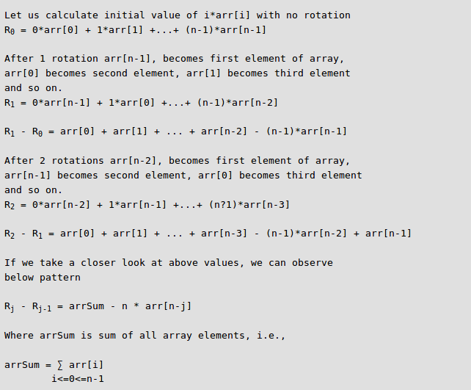
7) Find Multiple left rotations of the array

Algos: Using Reversal algo, block swap, juggling algo

Algo2: Time complexity : O(kn) , Space complexity: O(2n)

Step 1 : Copy the entire array two times in temp[0..2n-1] array.
Step 2 : Starting position of array after k rotations in temp[] will be k % n. We do k
Step 3 : Print temp[] array from k % n to k % n + n.

